Jessica Castro, Gary Sanchez, Hayden Shirk, Tristin Rodak, Ethan Arrieta
Final Challenge Test Cases
ECE131L Spring 2026
27 April 2026
Final Challenge Test Plan Cases Documentation
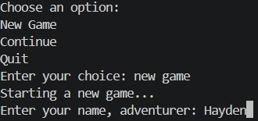
- Main Menu Choices
- Scan Option
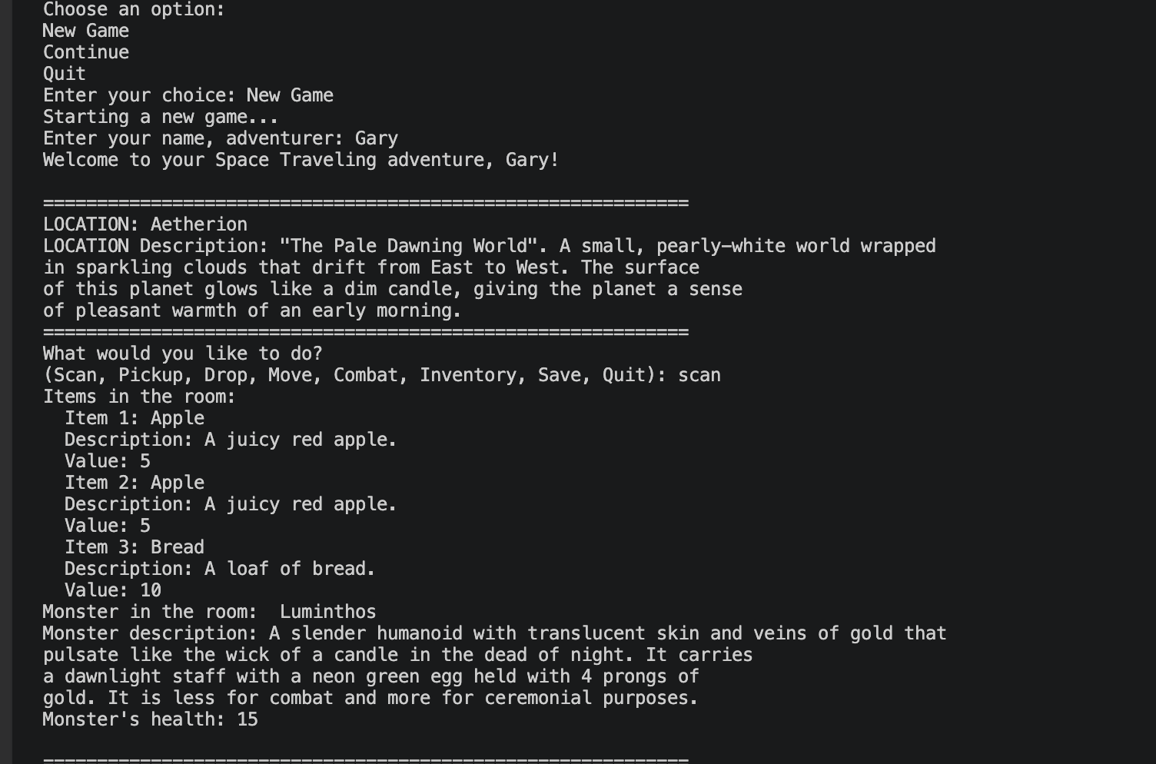
- Inventory Option: showing it can accept upper and lower case letters
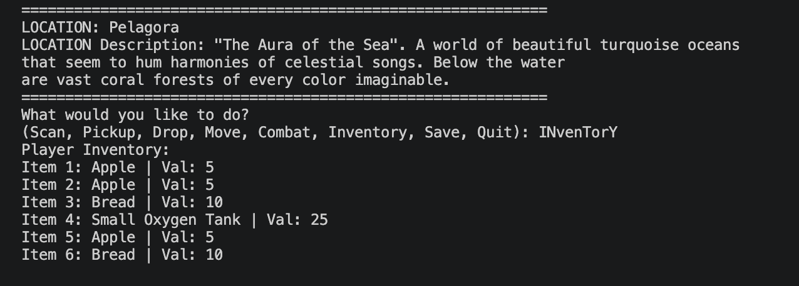
- Edge Case: Showing game cannot pick up items until the monster is defeated
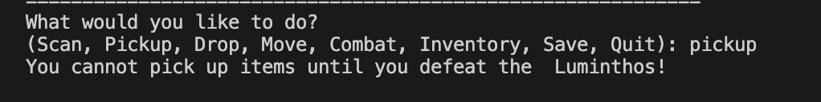
- Combat Options
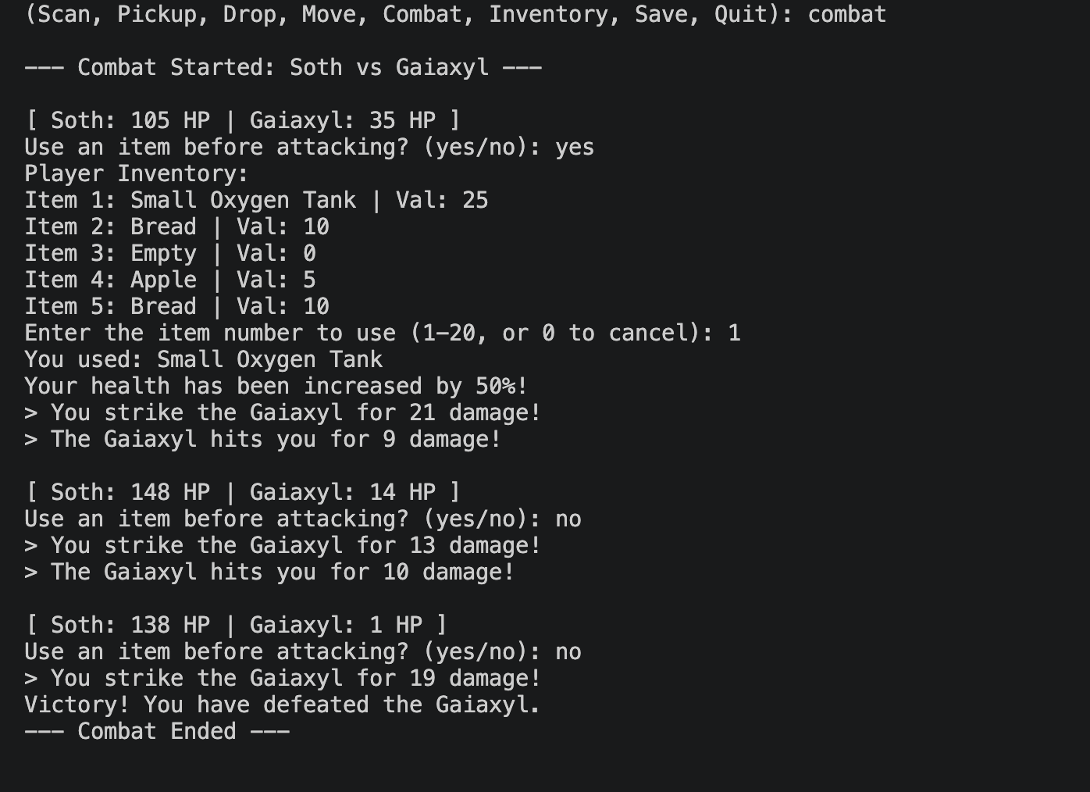
- Pickup item, drop item, and pick item up again 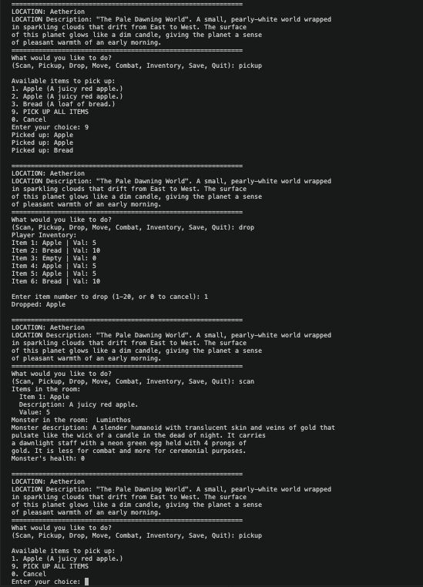
- Invalid Inputs of Menu Selection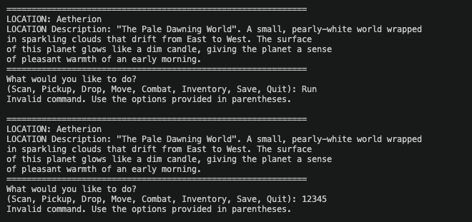
- How many rooms can you go with using an item? Is the game too tough?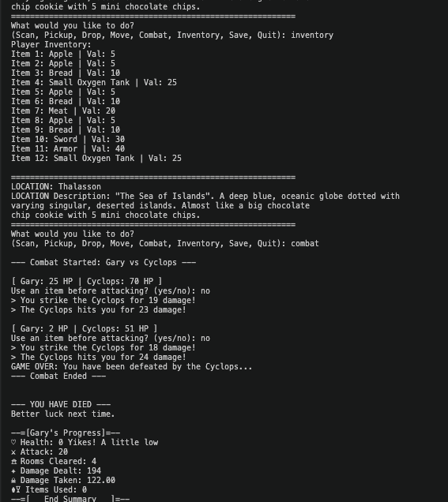
Four rooms cleared with no item use, twelve items in inventory

